Nick Brittingham

**Activity 2.1.2 Your Favorite Web Page**

Introduction

|  |  |
| --- | --- |
| What is your favorite web page? Why do you like it so much? There are a number of factors that contribute to the creation of an effective website. What are they?  Even if you have created a wonderful website, how are people going to find it or even find out about it? |  |

Materials

* Writing utensil
* Computer with Internet access and Firefox with Firebug installed

Procedure

1. Form groups of three or four as directed by your teacher. Meet or greet each of the other members of your group, practicing your personal and professional skills.

**Part I: Your Favorite Website**

1. The "name" of a web page might be a URL, filename, or <title> elements that get used by **broswer tabs**, **bookmarks**, and show up in the **history**. The content can also suggest a name for the web page. Write down a name for your favorite website here. Bungi. net

https://www.bungie.net/

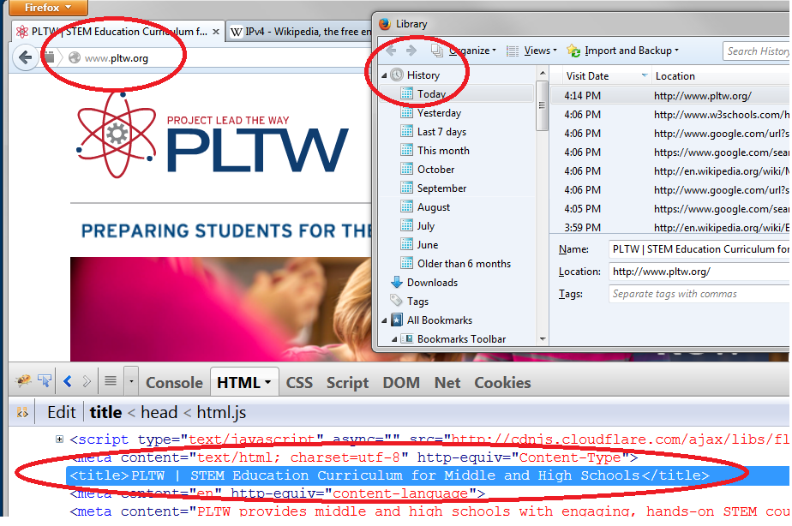

1. Load your favorite website in the **browser**. The browser, like Firefox or Chrome, is a **client application** running on the computer at which you are working, which is the **client machine**. The browser exchanges **TCP/IP** packets with the server to open a connection, request the web page, and get the content. Most packets on the Internet are TCP/IP packets and follow two protocols.

If a user has visitied that website from the computer you are now using, you might be seeing a cached page. A cached page is a page previously loaded from the web server and saved on the local client so that it can be viewed again quickly wiuthout getting a fresh copy from the server. You can ensure that the browser loads a fresh page by using the Refresh button



Does the website load all at once or in pieces?

All at once. Technicaly in pieces

1. Think back to your experience sending packets across the classroom. Why is it advantageous for a client and server to exchange information in packets? What is a disadvantage of using packets? if packets are lost it can still load the page. Has to reassemble packets.
2. The web page that was just transmitted to you was sent using packets. Why would this page load all at once when cached as opposed to in pieces when you hit “refresh”? because it checked the time stamps and it saw that the page was still current. So it relaunched the page.
3. Evaluate the website for usability using the principles of HCI discussed in the last lesson.
   1. Structure: The interface should be organized, putting related elements together. Organized all information is accessable
   2. Simple: Common tasks should be easy. Not simple but fairly easy to use
   3. Visible: Information and options should be easy to find, without the distraction of unnecessary information. All information is easily accessed through main page
   4. Feedback: User should be informed of actions, changes in state, and errors.
   5. Tolerance: Mistakes should be easy to undo and reasonable input should be interpreted.only editable from site owner
   6. Reuse: Design should be consistent across components. Design is consistant
4. For what audience was this site intended and how effective is it at tailoring to that audience? What makes it effective or ineffective? The site is intended for fans of the game who are looking for the site so it s designed to keep fans up to date and let them access information about the game. It presents links to all services of the website. There is a lot of info on the page and to access much of the information you need to sign in.
5. How reliable, believeable, or authoritative is the information presented on this site and how do you know? Absolutely reliable and correct it comes directly from the company that makes the game.
6. Consider how you would access this site if you were color blind, vision impaired, blind, or deaf. How much would it change your experience? In what ways and to what extent? it would be harder to use and the cluter of links would make it difficult to know what all I can get to and finding what I want.
7. Take turns presenting to the group about the website you, the presenter, analyzed. Direct your web browser to each person’s site in the group before that person presents their site. Each presentation should address each of the following qualities: audience, reliability, and accessibility. Two minutes per presentation.
8. Choose one of the other websites that was shared in your group and compare and contrast its qualities with the qualities that yours exhibits.
9. Web pages, like other information on the web, are sent from server to client as packets. Thinking back to the last activity, would you still be able to view a web page hosted on the left side of the room from the right side of the room if one of the routers in the middle went out of service?
10. The physical structure of the Internet has a lot of **redundancy**, meaning multiple systems that accomplish the same thing.

The diagram below includes a client (host #1) that is being sent a page from the server (host #12). If host #2 goes down, the packets will not be successfully transported. Similarly, if BOTH host #11 AND the link from #10 to #12 go down, packets will not be transported.

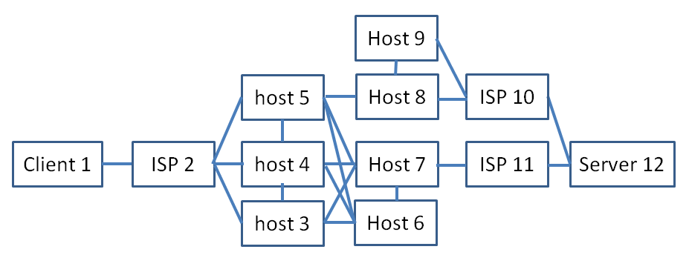

1. Why do you think that the routes traveled by packets on the Internet are usually least redundant near the beginning and end of their journey?

**Part II: Request and Response**

When you enter a web address into your browser, three sets of exchanges occur:

* Your computer uses domain name servers to get the IP address of the web server.
* Your computer exchanges SYN-ACKs with the webserver to open a connection (more on that in a later activity).
* Your computer sends an http request. Then the webserver sends an http response and closes the connection.

Understanding request and response can help you find what you're looking for, analyze content for reliability, and protect the security and privacy of your information.

1. The **URL** (Uniform Resource Locator) of a website is how you direct your browser to a specific site. Shown below is an example of a URL within the address bar of a web browser.

A URL starts with a scheme such as file or http. The scheme is usually a protocol for exchanging information such as http, https, or ftp, followed by a colon and two slashes "://". After the scheme or protocol, the URL has a domain name or IP address, then a slash, and finally a full path to the resource that we want to view in the browser. 2.1.2a ParsingURLs.docx contains a table to help you understand the parts of a URL and provides rows for you to diagram other URLs. These examples are referenced in the following paragraphs.

In the first example, the protocol is https and the domain is mail.example.com. The path to the resource is news/current/index.html.

After the question mark is a set of parameters passed to the website by your browser. **Parameters** are a lot like arguments in *Python*® programming language. The list of parameters begins with the question mark, and each parameter is separated from the others by an ampersand (&). For example, the parameter x in example one is assigned the value 35.

Some URLs, like the second example, include a colon followed by a number between the host name and the slash preceding the resource path. This number indicates the **port** on the server that is being accessed. Port numbers are used by software and hardware to **filter** packets. A filter only lets some packets through. Unencrypted web traffic typically uses port 80, and the the :80 can be omitted from the URL.

Use the accompanying worksheet, 2.1.2a ParsingURLs.docx, to parse the following URL for practice along with any others your teacher provides.

<http://samplehs.pltwcs.org/students/bkiGag3/sample.php?f=2>

1. Consider the following URL. Match the components of the URL in the left column with the component names in the right column.

https://free.coolsite.com:443/index/page1.html?x=1&y=3

|  |  |
| --- | --- |
| https  free.cool.site  443  index/  page1.html  x  1  y  3 | 1. Port 2. path 3. parameter #1 key 4. parameter #1 value 5. parameter #2 key 6. parameter #2 value 7. resource name 8. host name 9. scheme or protocol |

1. It is likely that you use http as your connection protocol most of the time. This protocol specifies what information the client and server will place in the body of the TCP packet and how it will be formatted. The TCP packet is in turn contained within the body of an IP packet and the HTTP packet contains as its payload the actual HTML code for a website. The image shown below is a diagram of this nested packet structure.

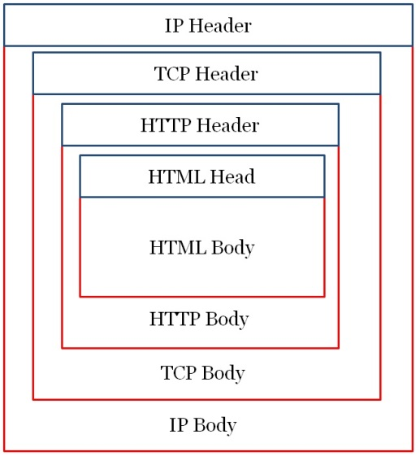

Why do you think it might take many packets to assemble a web page within your browser?

**Part III. Your Digital Footprint**

What enduring bits are left behind by your activities on the Web?

Requesting a web page by its domain name causes chatter among name servers. What other network traffic is generated when you browse the Web? In this section, we look at cookies. What information about you gets stored, and by whom? This question reaches into issues of democracy, power, privacy, and more. In this section we consider cookies, a way that information about you is stored by web servers on your own machine.

1. A **cookie** is a small amount of data stored on the client machine. In order to view your cookies for one web page, turn on Firebug in Firefox by clicking its icon in the navigation bar shown below. Firebug is not built into Firefox; it is an Add-on. **Add-ons** are separate pieces of software that interact with another to extend its functionality. In this activity Firebug serves to allow us to examine websites in greater detail and provides some additional functionality beyond what is available in traditional browser-based tools like the “View Source” option that we will use later in this activity.

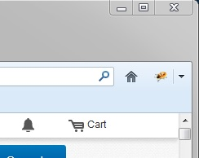

Switch to the “Net” tab in Firebug and then select “HTML” as shown below.

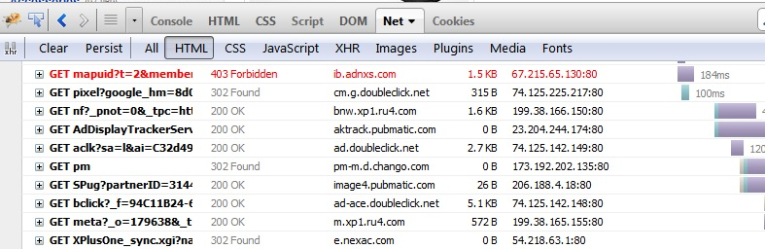

Direct your browser to ebay.com and do a search for something you are interested in buying. As you can see in Firebug, much of the HTML that your computer is viewing is provided by sources other than ebay.com. Name two of these other domains.

1. Switch to the “Cookies” tab in Firebug as shown below.

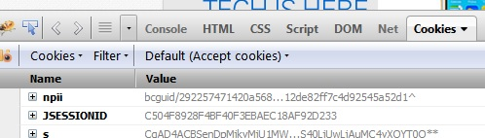

Web programmers use cookies to do things like remember your preferences, history, shopping cart, or login status. Each set of cookies is associated with a domain name and with a directory path on that host. So a cookie can be specific to one web page or can be shared across a web site. Cookies cannot be accessed by a server outside their domain, so a page at mail.google.com can access a cookie associated with google.com but not one associated with ebay.com. The cookies tab in Firebug lets you view the details of each cookie created or accessed when you visit a site. It provides the following information:

* 1. Cookie Name
  2. The value of the cookie, which is the actual information being accessed by the site
  3. The domain that is accessing the cookie
  4. The size of the cookie
  5. The expiry date and time among other details.

Choose one of the cookies that you can see and record its name, domain, size, and expiration date/time.

|  |  |  |  |
| --- | --- | --- | --- |
| cookie name | domain | size | expires |
|  |  |  |  |

1. Now search for something on ebay and examine how the number and variety of cookies changes. Before your search, most if not all of the cookies should have belonged to the ebay domain. To whom do they belong now? List several different domains.
2. These cookies being accessed by domains other than ebay.com are called **third-party cookies.** Use the Internet to find out more about the domains that are accessing your cookies when you searched for something on ebay. Who are the entities using these domains and what do they do? Choose at least one to examine at this level of detail and then share what you found with 3-5 other students.

**Part IV. What Web Pages are Made Of**

1. Web pages are written in Hypertext Markup Language (**HTML**). The HTML can include other languages, like Cascading Style Sheets (**CSS**) and **JavaScript**. You will learn a more about these langauges in a later activity.

Web pages are rendered by the client machine's browser. Different browsers render the page differently. They are configurable by the user. So neither the server nor the client can know how a web page should be displayed without information from the other. Look at the source code that was sent to the client to display this web page. Navigate back to ebay.com if you’ve left it. Select **Firefox** > **Web** **Developer** > **Page Source** (Ctrl-U). Firefox should create a new window filled with text. The text is the source code for the page. Use the Firefox “Find” tool (Ctrl-F) to search the text for word “meta”. How many lines do you find that contain this word?

1. Switch from the Cookies tab to the HTML tab in Firebug and click on the + sign in the box next to the characters “<head>” in order to view the scripts and metadata for this site as shown below.

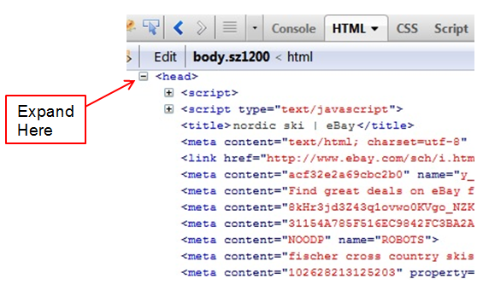

This displays the source code of the web page. For now we are interested only in the lines beginning with “<meta ...>”. Look at each of these lines to find the one that contains a list of key words separated by commas. These key words used to be used heavily by search engines to help determine their search results. Watch the following video and describe why Google now chooses not to use these key words in determining their search results:

<http://www.youtube.com/watch?v=jK7IPbnmvVU>

1. Navigate to your favorite web page and use Firebug to examine it. Did you find any unexpected third-party cookies. If so, for what domains?
2. What metadata does your favorite site contain, if any?
3. We will now use Firebug to revisit the question of accessibility for your website. One important design concern when developing a website is the ability of text-to-speech readers to process images. To this end, img tags in HTML have an “alt” property which can be used to provide alternate text to be displayed in the event that the image cannot be loaded or the user cannot see the image. On your favorite webpage (or another if yours has no images), mouse over parts of the HTML until an image appears highlighted in the browser as shown below. This should help you expand the code necessary to find the img tag and check to see if it has alternate text. What site did you visit and what was the alternate text on the image if any? Was it sufficient to give a good idea of what the image that was placed there was to someone who could not see it?

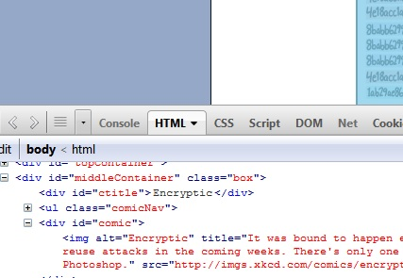

Alternate Text

Highlighted Image

**Part III: Search**

Search engines are one of the most powerful ways to quickly access the data you want on the web. Search engines typically use **web crawlers** or spiders, autonomous softbots that examine the pages on the web by passing from link to link, aggregating all of the information that they discover into a massive database called a **web index**. Search engines then use their own algorithms to determine relevance of the sites that they have indexed to a given query and return results back to the user. The words that you type into the search field of a search engine form the **query**.

1. Use this information and optionally the video found at <http://www.google.com/intl/en_us/insidesearch/howsearchworks/algorithms.html> to answer the question “What role do algorithms play in determining search results?”.
2. After watching the following video, use the information you gained to try and answer why some web pages might not be returned as search results even if they are relevant to your query. <http://www.youtube.com/watch?v=BNHR6IQJGZs>
3. Even today one of the most important skills you can learn is how to effectively format your search queries. Higher quality queries get you better results in less time, leaving you more time for everything else. They help you conduct research, find images or videos, and locate communities for discussion of various topics. Some of the best tips for improving your searches are incredibly basic: be as specific as you can, consider the type of vocabulary that is likely to appear on sites that you want to see, and keep your queries simple. You can get a lot trickier if you have specific criteria for your search. Use this page provided by Google to answer the following questions: <http://www.google.com/intl/en_us/insidesearch/tipstricks/all.html>
   1. You want to search for Mustangs but not the car, just the horse. What search operator would you use to ignore sites about cars?
   2. You want to find PowerPoint slides about a given topic. How can you get results that contain only .ppt compatible documents?
   3. You saw a really interesting article about whales on cnn.com, but it’s been a few days and you can’t find it by searching for whales anymore. How can you narrow down your search and only get results from cnn.com?
4. Search is a powerful tool for many reasons. Analysis of search query data has revealed that by using Google Flu Trends, researchers were able to predict the outbreak of flu cases more than a week in advance of the CDC (Centers for Disease Control). Google’s trend search feature shows a visualization of the data that they have collected about what people search for and when. The data is crowd sourced: people all over the world are the ones doing the searching. All Google has to do is record what they searched for, when, and then analyze the data.

**Note:** Google limits the number of requests to Google Trends per IP address. Refrain from submitting extras until everyone in your class has finished.

Navigate to google.com/trends and search for “flu”. When did people start really worrying about Swine Flu?

1. What else might you be able to predict using a visualization like Google trends? Conduct a search and note any patterns that you found here.
2. Describe a strategy for using Google trends to buy your best friend the most popular Christmas gift.
3. Google is certainly a popular search engine though by no means the only one. In your group of 3 or 4, brainstorm a total of 5 queries and decide upon 3 search engines to test on those queries. Examine the first 10 results in each engine and record your comments and analysis here.

|  |  |  |  |
| --- | --- | --- | --- |
| Engine Names | A. www.google.com | B. www.google.cn | C. www.bing.com |
| Queries |  |  |  |
| 1 |  |  |  |
| 2 |  |  |  |
| 3 |  |  |  |
| 4 |  |  |  |
| 5 |  |  |  |

1. Which search engine’s algorithm do you think performed the best, and why?
2. For one final search engine comparison, you will compare the image results for a query including just the word “democracy” on google.com vs. google.com/hk . Note what you observe below.
3. The differences that you are noticing are evidence of the fact that governments have influence over the infrastructure of networks.
4. Owners of individual domains get to decide what content is published on their websites. Why might this autonomy be important to the development of the Internet?

Conclusion

1. We barely even looked at any code in this activity. Why do you think that knowing about the protocols and features of the web might be useful to you as:
   1. An informed citizen:
   2. A professional developer:
2. How do various factors influence the results that different search engines produce?
3. How can crowdsourced data about search trends help predict the future?
4. From the standpoint of the governing bodies of .com, why is it important that owners of individual domains maintain authoritative records of their subdomains and manage the content that is published on their sites? (Hint: think about what the alternative would be.)
5. If the most direct route for packets representing a webpage that you have requested from their server to you is broken (hardware goes down for some reason) what happens to the packets?
6. What makes for a high quality website?
7. What is the basic function of the cookie and where is it stored?